

Wastewater and Sewage Spill Prevention

Consultants:

Haylea Elliff : Project Manager

Alexandra Thompson : Water Resource Specialist

Jasi Mitchell : GIS Analyst & Editor

Joseph Berenji : GIS Specialist

Justin Williams : GIS Analyst & Web Developer

**February 26th, 2018**

**Vulnerability Analysis and Visualization of Sewage Spills in Edwards Aquifer TCEQ Regions 11 and 13 from 2012 to 2017**

**Prepared for:** 

**Prepared by: Waste Water and Sewage Spill Prevention (W.A.S.S.P)**



**I**

**TABLE OF CONTENTS**

**1. INTRODUCTION**

1.1 Summary………………………………………………………..…………….1

1.2 Purpose………………………………………………………...………….......1

1.3 Scope……………………………………………………...…………………..2

**2. LITERATURE REVIEW**…………………………………………………………….3

**3. PROPOSAL**

3.1 Data…………………………………………………………...……………….4

3.2 Methodology…………………………………………………………………..6

3.3 Implications…………………………………………………………………...10

3.4 Budget………………………………………………………….……………...10

3.5 Timetable……………………………………………..……………………….11

3.6 Final Deliverables……………………………………...….…………....……..12

**4. CONCLUSION**………………………………………………….....………………….12

**5. REFERENCES**………………………………………………………………………..13

**6. PARTICIPATION**

**II**

1. **Introduction**

1.1 Summary

Previously, a Texas State project had been conducted on the visualization of the raw sewage spills in TCEQ regions 11 and 13 for years 2006 through 2012. Their product was an interactive map with spill location and attributes. Our first goal is to update this map, with a similar objective. This will be done through using more recent years of 2012 through 2017 and applying available attributes in same style as the previous interactive map. Next, we will conduct a vulnerability analysis to visualize the areas of the Edwards Aquifer that are sensitive to sewage spills. The vulnerability analysis will be conducted through a GIS suitability analysis or other appropriate method that is applicable to the available data. The purpose of these maps is to provide accessible knowledge of the aquifer conditions to the public and to law making and regulator entities. Finally, we will make recommendations for future record keeping and processes of updates to these maps.

1.2 Purpose

The Edwards Aquifer provides drinking water for approximately 2 million people and significantly contributes to the Texas economy by means of irrigation for agriculture. (Greater Edwards Aquifer Alliance (GEAA 2014). The Edwards Aquifer is naturally relatively clean in quality and requires little maintenance other than mild treatment by chlorine or fluoride, unless contaminated (GEAA 2014). Fig. 1 provides an example of the hydrological cycle and flow of surface infiltration. Sewage spills that occur on the surface and from underground sewage lines could make their way into the stream and springs that feed into the aquifer, including wells used for domestic and livestock purposes. Contamination of the Edwards Aquifer would pose health risks to thousands of people, affect endangered species, harm crops and livestock, and raise the cost of water maintenance that directly affects consumers. These costs would be felt both by municipalities and agricultural land owners. The Edwards Aquifer is especially vulnerable to pollution due to the karst topography. The underlying limestone is very porous, allowing water, and pollutants, to penetrate and recharge the aquifer quickly. Due to this, the TCEQ named the Edwards Aquifer the most vulnerable aquifer in the state to pollution (GEAA 2014). The growing cities and development over the Aquifer increases pollution potential from urban runoff and infrastructure, like sewage leaks over the recharge zones.

This project will update previous maps of sewage spills located in the Texas Commission on Environmental Quality (TCEQ) regions 11 and 13 in the Edwards Aquifer after 2012 until 2017 that have been an outlet for public access and education. The vulnerability analysis provides information to environmental scientists, municipalities, the Edwards Aquifer Groundwater District, and the public to educate the current conditions of the aquifer over the last 5 years. Through our analysis we can determine whether or not there has been an increased or decreased in spills in region 13, after the initiation of sewage repairs, and recommend a way to categorize spill types by how much they can affect the aquifer.

Figure 1. The hydrologic cycle, the infiltration of water. (USGS 2016)

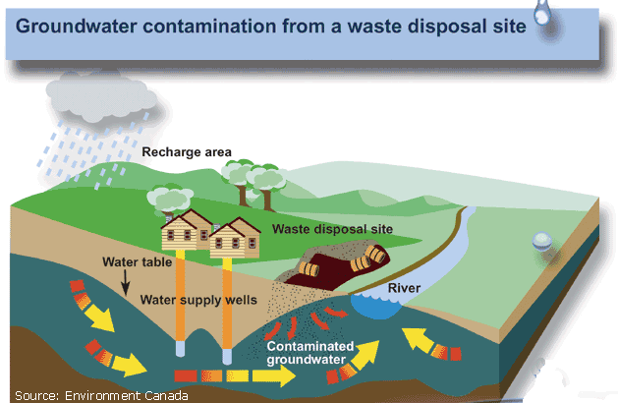

1.3 Scope

The project will focus on raw sewage spills that have occurred between the years 2012 and 2017 in the TCEQ regions 11 and 13 in the Edwards Aquifer. The priority order of the main counties are as follows: Hays, Comal, Bexar, Travis, Medina, Uvalde, Kinney.

Fig. 2 Project study area.

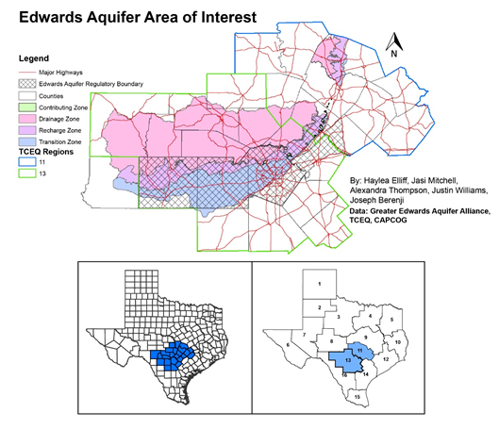

**2. Literature Review**

San Antonio, America's 7th largest city, and surrounding cities have been able to develop over the last two centuries due to the Edwards Aquifer. The Edwards Aquifer is considered one of Earth’s greatest natural resources that promotes a diverse range of needs for almost two million people. There is an increasing demand for the Edwards Aquifer which has exceeded its capacity, thus raising concern for the sustainability of the economies, endangered species, and public utilities that depend on the aquifer. To have sustainable management, the limitations of the Aquifer must be recognized (Eckhardt 2000).

In 2013, San Antonio Water System (SAWS) was charged a $2.6 million civil penalty from illegal discharge of raw sewage and were to make $1.1 billion in sewer system upgrades. SAWS had approximately 2,200 illegal overflows discharging roughly 23 million gallons of raw sewage into local waterways between 2006 and 2012. The overflows of discharge were largely based on heavy rainfalls overwhelming the system capacity and spilling over into local waterways. The improvements are to aid the long-term operation, management, and maintenance of the sewage system and expected to benefit over a million people in Bexar county and are to be fully implemented by 2025 (U.S. Department of Justice 2013).

Vulnerability assessments on the Edwards Aquifer have been done in the past, using the topography and geology of the area. Allan Clark assessed the vulnerability of groundwater to contamination in 1998 using an adaption of Texas Natural Resource Conservation Commission (TNRCC) geologic assessment for recharge rates, a weighted environmental impact method developed by Leopold and others in 1971, and the DRASTIC method (Clark 1998). DRASTIC is an acronym for Depth to Groundwater, Net Recharge, Aquifer Media, Soil Media, General Topography or Slope, Vadose Zone, and Hydraulic Conductivity of the Aquifer (Clark 1998).

The variables used in Clark’s vulnerability assessment were set by him, ranked and weighted. The natural features included in this study were hydrogeologic units, faults, caves, sinkholes, slopes, and soil permeability. (Clark 1998) Some examples of high vulnerability rankings were caves, or hydrogeologic units from the Kainer Formation. Features were given a zero ranking if there were no caves, for example, present. In ArcMap, the datasets were converted from vector to raster, and were given a cumulative rating. (Clark 1998) Vector data models represent things with discrete points, lines, and polygons (sinkhole would be represented with a point, and soil type with a polygon). The raster data models a continuous surface, with cells representing information.

In 2011, the Texas State group Aquifer Resource Innovators mapped wastewater spills in Regions 11 and 13, from January 2004 to May 2012. They geocoded addresses of spills provided by TCEQ and then used ArcMap to convert the addresses to geographic coordinates. The data had some issues, the most significant being some locations recorded did not have a full address or was only a proximate location. In order include these locations, they used Google Maps and Google Earth to search for the geographic coordinates of the relative location descriptions. Their product was an interactive story map with the purpose of providing an accessible visualization to the public.

Our project aims to update the previous Texas State’s group project with more recent years, while adding another element of further analysis. We will be conducting a vulnerability analysis with the purpose of visualizing where the sensitive areas are of the Edwards Aquifer to further educate the public and regulators of the zone. The vulnerability analysis will improve the understanding of the aquifer’s fragility to stimulate concern and protection.

**3. Proposal**

3.1 Data

Data to be acquired:

* Wastewater Spill Locations (2012-2017) (EAA, TCEQ, MUDS)
* Locations of Wastewater Treatment Plants.
* Municipal Utility Districts Service Areas
* Streams and surface waters
* Edwards Aquifer zones (CAPCOG) (EAA)
* Locations of Wastewater Lines
* State and County Boundaries (TPWD)
* Major Roads (Census)
* Major Texas Cities (TNRIS)
* Geologic Database of Texas (TNRIS)
* Soil Media (TNRIS)
* Precipitation (NOAA)
* Surface wells (TNRIS)

The principle data for the project, sewage spills, will need to be acquired through TCEQ. An open records request to TCEQ was made on January 30th, 2018, their response has been received February 9, 2018 to which has informed us of a charge of $43.23 for a 10 MB file. On February 16th, 2018 the project manager went in person to view the files, however we not able to without payment. As a result, our group has forwarded the PIR identification number assign to TECQ’s file for the GEAA to obtain for us. Shapefiles for Texas counties, cities, roads, and landmarks along with the Edwards Aquifer zones are easily attainable through open source download at government and Edwards Aquifer Authority websites.

There is concern for the quality of data we will receive, there may not be GPS locations associated with the spill, hindering the accuracy of where the spill occurred. All the spills that occurred during that year may not have been reported or recorded correctly with duration, volume, incident and cleanup attributes. We would recommend to future groups working on this project to first place their open records request with TECQ as soon as possible, and then immediately contact the GEAA with the PIR number so that the office may obtain the data for them. As for the quality of the data we would recommend that the onsite management teams take more consideration on providing evidence of the incidents.

Fig. 3 Detailed master data list.

|  |  |  |  |  |
| --- | --- | --- | --- | --- |
| **Entity** | **Attributes** | **Spatial Object** | **Status** | **Source** |
| Texas Base Map | County names, Area, Delineated Counties | Polygon | Available | Esri, TCEQ |
| Edwards Aquifer | Zones, Area: Acres, Sq. Feet, Sq. Miles | Polygon | Available | TCEQ |
| Edwards Aquifer Regulatory Boundary | Shape | Polygon | Available | TCEQ |
| Major Roads | Name, Type | Line | Available | Census Bureau, Esri, TxDOT |
| Pt. Source Wastewater events | Location, NPDES-number, Permitee, Volume, Duration, Clean up status, Depth | Point | Pending | GEAA, TCEQ, PUC |
| Wastewater Treatment Plants | Location | Point | Pending | Government Online Source |
| Municipal Utility District Service Area | Name, Addresses | Polygon | Pending | PUC |
| Surface Water | Name, Type, Basin, Impairment Status | Line/Polygon | Available | USGS |
| TCEQ Regions | Name | Polygon | Available | TECQ |
| Geology of Study Area | Type of Media, Extent, Depth, Location of Fault Lines | Polygon | Available | USGS, TNM |
| Soil Types | Type, Extent | Polygon | Available | USGS |
| PWS Surface Wells | Location, Depth to Water Table. | Point | Available | TCEQ |
| DEM of Study Area | Elevation | Raster | Available | TNM |

3.2 Methodology

For the purpose of assessing the potential sensitivity of the Edwards Aquifer to wastewater contamination, our project utilizes a system generated by the US EPA for analyzing groundwater pollution potential based on hydrogeologic factors: depth to water table, net recharge, aquifer media, soil media, topography, impact of the vadose zone, and the hydraulic conductivity of the aquifer. While DRASTIC modeling provides a universal framework, its effectiveness is ultimately dependent on the user’s geographic knowledge of the region, due to the need to merge both qualitative (soil media, aquifer media, etc.) and quantitative (net recharge, depth to water table, etc.) data types. This process of data standardization can be broken down into three essential components: weights, ratings, and ranges (Aller, Bennett, Lehr, Petty 1985). Considered to be a constant, weights involve the significance of the hydrogeologic factor associated with each factors significance in recharge of the aquifer as defined in Table 1 (Aller, Bennett, Lehr, Petty 1985). Additionally, DRASTIC factors are separated into either ranges or noteworthy media types impacting contaminant transport potential, where they will be categorized through individual ratings; which are described in Tables 2-8 (Aller, Bennett, Lehr, Petty 1985). These components combined through a model are used when calculating DRASTIC index.

Tables 1-8. Classification hydrogeologic features defining associated ranges and ratings.

(Aller, Bennett, Lehr, Petty 1985)

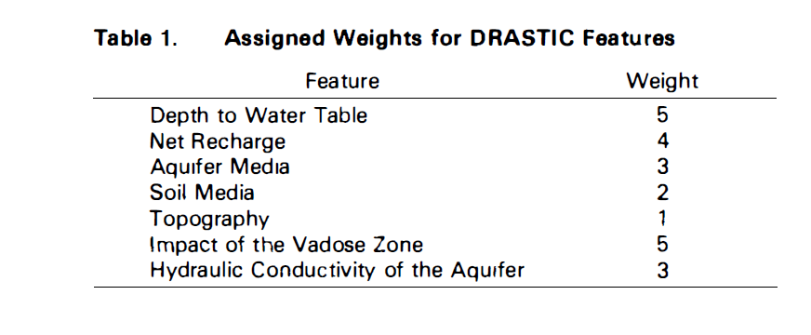

The model calculation for defining DRASTIC index is:

DRDW + RRRW + ARAW + SRSW + TRTW

+ IRIW + CRCW = DRASTIC index

where:

XR = rating

XW = weight

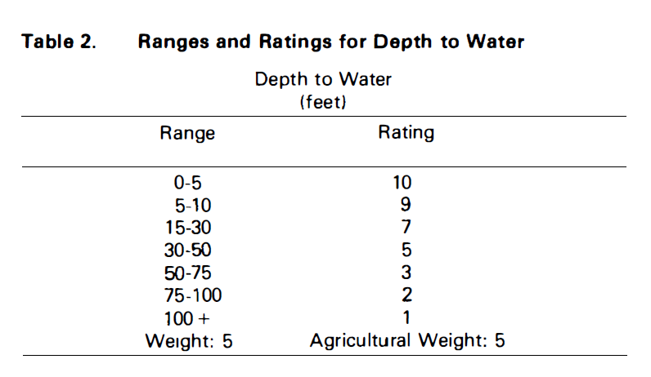

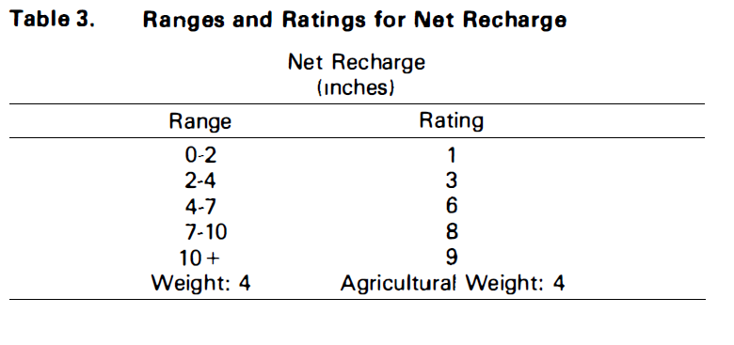

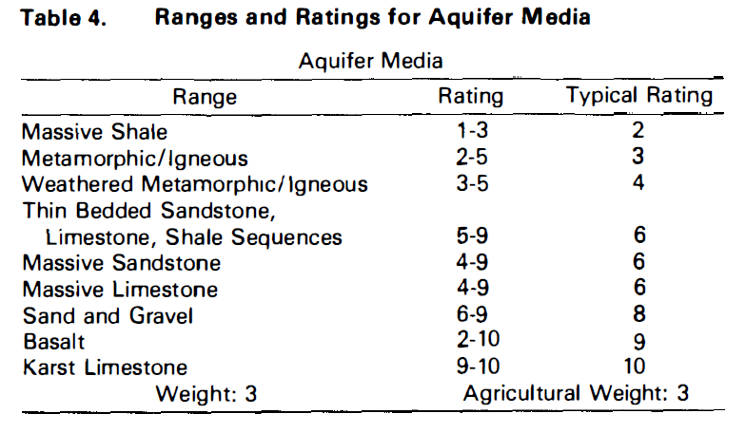

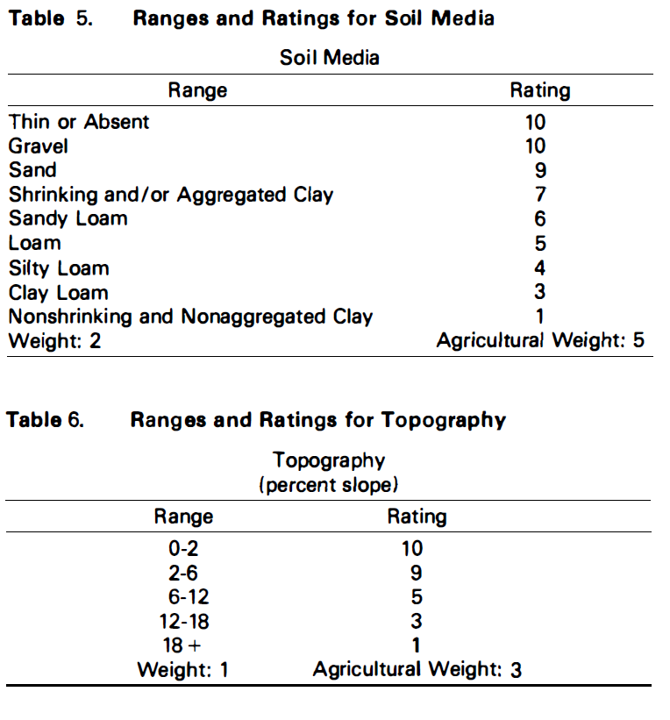

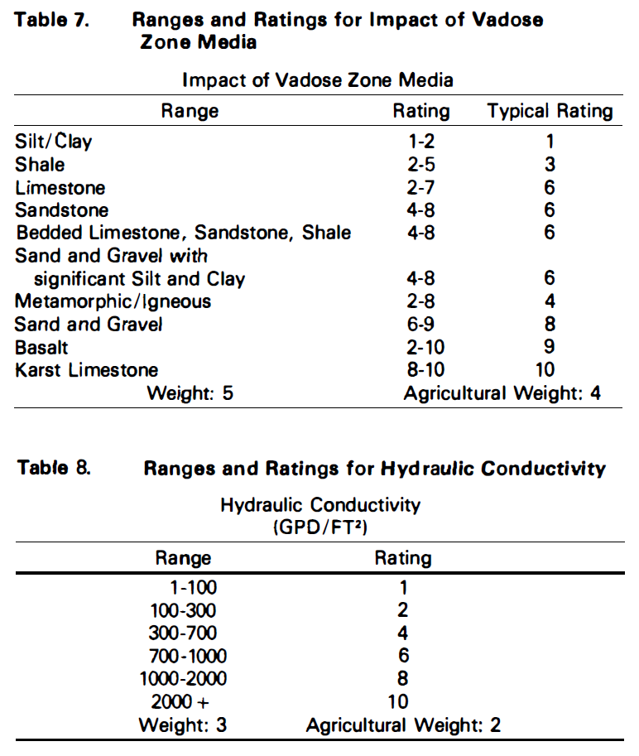

While regarded primarily as a tool for comparative assessment, calculating DRASTIC index presents a means to locate areas that present a greater risk for groundwater contamination relative to one another (Aller, Bennett, Lehr, Petty 1985). Applying the DRASTIC framework in a Geographic Information System, provides a deeper insight into the potential impacts associated with wastewater contamination in the groundwater quality of the Edwards Aquifer through the visualization of regional vulnerability. In a GIS, individual Hydrogeologic features will be displayed as cost raster’s; features comprised of quantitative data (D, R, T, C), will be determined through means of spatial interpolation, whereas qualitative data (A, S, I) will be converted from vector polygons. Once surfaces have been generated for each hydrogeologic factor corresponding ranges and media types shall be identified according to the hydrogeological characteristics of TCEQ regions 11 and 13. Following the identification and classification of DRASTIC model parameters unique to the Edwards Aquifer and surrounding areas, the previously outlined equation will be implemented into the raster calculator function available through Esri’s ArcGIS software to create a surface displaying DRASTIC index for the study area, which will be used to identify the spatial distribution of potential groundwater vulnerability.

Contingent on the availability of wastewater infrastructure data in addition to compliance records for the locations of structural failures of wastewater systems, our next plan of action necessitates the observation of spatiotemporal trends related to the distribution of spill events from 2012-2017. Presently, the acquisition of spatial data specifying positions of wastewater infrastructure systems would allow for a comparison between the density of in-ground wastewater structures and the sensitivity to potential pollutants.

To build upon ensuing results, the subsequent stage of this mission intends to quantify the degree of methodological accuracy; wherein spill events occurring over the period of study would be cross referenced with historical water quality data, based on DRASTIC estimations concerning the time it takes for contaminants to reach the aquifer, and flow characteristics determined by hydraulic conductivity and the hydraulic gradients unique to the Edwards Aquifer. The combination of real-time wastewater pollution data accompanied by the comprehensive DRASTIC index surface, presented via a publicly available online story map will aid in the visualization of possible ecological degradation. Through the interactive interface of story maps, this knowledge can be relayed to the communities dependent on the Edwards Aquifer in a way that strengthens awareness and education.

**3.3 Implications**

The construction of an improved story map allows communities dependent upon the Edwards Aquifer to have direct access to a detailed assessment of wastewater infrastructure, as well as valuable knowledge about the local environment. The maps made available through ArcMap online, allows for users whom might not have a geographical background to get a fundamental understanding about the interconnectivity of our environment and the implications of pollution, i.e. sewage spills. More importantly, by overlaying regional wastewater infrastructure data, in conjunction with latent exposure introduced by previous spills we hope to raise awareness for our valuable and fragile environment. This map will also be useful for remediation and conservation practices by GEAA, local regulatory entities and non-profit organizations within the community upon spill occurrence. We hope that with the information provided and the production of this detailed map that it will also aid the Edwards Aquifer Authority with regulations for conservation and protection of the aquifer as well.

We aim to devise a standardized ranking structure for the potential susceptibility of groundwater to contaminants in the pursuit to better understand impact on the aquifer. Apart from DRASTIC parameters, we contemplated the potential benefits of having a system in place to record information relating to volume of released pollutants. For example, if we we could quantify rate of discharge and the duration, we could create more accurate models for mapping the transport of pollutants in a highly karst unconfined aquifer such as the Edwards.

3.4 Budget

The proposed budget consists of wages, equipment, software, and depreciation, however please note it does not include overhead costs. Glassdoor, adobe, and ESRI websites were used to determine costs on wages and software.

Fig. 4 Project budget.

|  |  |  |
| --- | --- | --- |
| System Management | | |
| Project Manager (10 hrs/week for 12 weeks) | | |
|  | Total Hours | 120 |
|  | Hourly Pay | $60.00 |
|  | Sub-total | $7,200 |
| GIS Analyst (10 hrs/week for 12 weeks * 4 consultants) | | |
|  | Total Hours | 480 |
|  | Hourly Pay | $30 |
|  | Sub-total | $14,400 |
| Total | | $ 21,600 |
| Equipment | | |
| Workstation | $110/workstation * 5 workstations | $550 |
| Maintenance | $150/workstation * 5 workstations | $750 |
| Data | TECQ acquired | $43.20 |
| Depreciation | $150,000 value of equipment/48 equip  life in months * 3 months equipment in use | $9,375 |
| ArcGIS | $4,800/year (Standard w/ all extensions) $4,800/12 * 2 months | $800 |
| Adobe Illustrator | $50/ month * 1 month | $50 |
| Travel | To each regions TECQ locations | $50 |
| Total |  | $11,618.20 |
| Grand Total Cost* *does not include overhead costs | | |
| $33,218.20 | | |

3.5 Timetable

The following timeline is a general outline for the project to follow. The detailed schedule is subject to change with the momentum of the project. There are notes included to remind the group of the breaks in classes for spring break and the AAG meeting that may have effect of the productivity of that week depending on the students’ availability and access to campus resources.

Fig. 5 Project timeline.

|  |  |
| --- | --- |
| **Week 1** | RFB Receival and Initial Project Concepts |
| **Week 2 & 3** | Data Acquisition |
| **Week 4 & 5** | Composition of Proposal |
| **Feb 21** | Proposal Presentation Rehearsal |
| **Feb 26** | Proposal Presentation, 2nd Client Meeting |
| **Week 6 & 7** | Data Analysis, Creating Maps |
| **Week 9 & 10** | Progress Report and Presentation, 3rd Client Meeting |
| **March 26th** | Progress Report |
| **Week 11** | Composition of Story Map |
| **Week 13 & 14 & 15** | Composition of Final Report |
| **April 25** | Final Report Presentation Rehearsal  All Final Deliverables due by 4:00pm |
| **April 30** | Final Presentation |
| **Notes** | Important Dates, Week 8 & 12 are not in session |

3.6 Final Deliverables

* Detailed Final Report
* Professional Poster
* Spreadsheet containing wastewater spill data and attributes
* Hard copy Spill/Vulnerability Map
* CD containing:
  + Metadata
  + Report
  + Poster
  + PowerPoint presentation
  + Updated interactive story map of spill identification (ArcGISonline)

The final delivery is an updated user-friendly story map displaying the sewage leaks in TECQ regions 11 and 13 of the Edwards Aquifer Recharge Zone. Within the story map, spill data, such as date, duration, and volume of the spill, will be made available through clickable/rollover information bubbles, like previous year project. We will place the raw data in accessible formats, such as spreadsheets, word documents, and shapefiles, on a CD for the client’s future use. All final deliverables are due April 25, 2018 by 4:00pm.

**4. Conclusion**

This project aims to update the previous maps of sewage spill information in TECQ regions 11 and 13 in the Edwards Aquifer from 2012 through 2017 by producing a user friendly interactive map for public access. The vulnerability analysis conducted to identify at risk areas of the Edwards Aquifer by using available sewage spill attributes. The results of this project are to provide public accessible resources that are of quality to influence regulating entities to protect the Edwards Aquifer with diligent force.

**5. References**

Aller, L., T. Bennett, J. H. Lehr, and R. J. Petty. 1985. *DRASTIC: A Standardized System for Evaluating Ground Water Pollution Potential Using Hydrogeologic Settings.* United States Environmental Protection Agency :1–177. https://nepis.epa.gov/Exe/ZyNET.exe/20007KU4.TXT?ZyActionD=ZyDocument&Client=EPA&Index=1986+Thru+1990&Docs=&Query=&Time=&EndTime=&SearchMethod=1&TocRestrict=n&Toc=&TocEntry=&QField=&QFieldYear=&QFieldMonth=&QFieldDay=&IntQFieldOp=0&ExtQFieldOp=0&XmlQuery=&File=D%3A%5Czyfiles%5CIndex%20Data%5C86thru90%5CTxt%5C00000001%5C20007KU4.txt&User=ANONYMOUS&Password=anonymous&SortMethod=h%7C-&MaximumDocuments=1&FuzzyDegree=0&ImageQuality=r75g8/r75g8/x150y150g16/i425&Display=hpfr&DefSeekPage=x&SearchBack=ZyActionL&Back=ZyActionS&BackDesc=Results%20page&MaximumPages=1&ZyEntry=1&SeekPage=x&ZyPURL (last accessed 23 February 2018).

Clark, A. K. 1998. *Vulnerability of Ground Water to Contamination, Edwards Aquifer Recharge Zone, Bexar County, Texas, 1998.* U.S. Geological Survey Water-Resources Investigations Report 00-4149. https://pubs.usgs.gov/wri/2000/4149/report.pdf(last accessed 23 February 2018).

Eckhardt, Gregg. 2000. *The Edwards Aquifer Website.* <http://www.edwardsaquifer.net/index.html> (last accessed 24 February 2018).

Roos, M., and A. Peace. 2014. *Watershed Stewardship for the Edwards Aquifer Region A low Impact Development Manual.* http://www.aquiferalliance.net/Library/GEAAPublications/GEAA_Manual.pdf(last accessed 23 February 2018).

U.S. Department of Justice. 2013. *San Antonio Agrees to $1.1 Billion Upgrade of Sewer Systems to Comply with Clean Water Act.* Office of Public Affairs. https://www.justice.gov/opa/pr/san-antonio-agrees-11-billion-upgrade-sewer-systems-comply-clean-water-act (last accessed 2 February 2018).

Zghibi, A., A. Merzougui, I. Chenini, K. Ergaieg, L. Zouhri, and J. Tarhouni. 2016. *Groundwater vulnerability analysis of Tunisian coastal aquifer: An application of DRASTIC index method in GIS environment.* Groundwater for Sustainable Development2-3:169–181. https://www.sciencedirect.com/science/article/pii/S2352801X16300431(last accessed 23 February 2018).

**6. Participation**  
Haylea Elliff : Project Manager

Alexandra Thompson : Water Resource Specialist

Jasi Mitchell : GIS Analyst & Editor

Joseph Berenji : GIS Specialist

Justin Williams : GIS Analyst & Web Developer